

EBAY CONTROLLER TEST DATA SHEET

P/N: 414-8005-95 Date: 12/04/2018

S/N: 287 Time: 09:27

UA: 95 Tested by: xs

Hardware Rev: BLDC_60A_V6 Approved by: xs

Software Rev:

Tester Software Version: 1.2k

Equipments Used

Equipments Model No Serial No

Power Supply

Digital Multimeter

CAN Interface

BLDC Tester

PC

Heater

RS-232 Interface

Current Meter

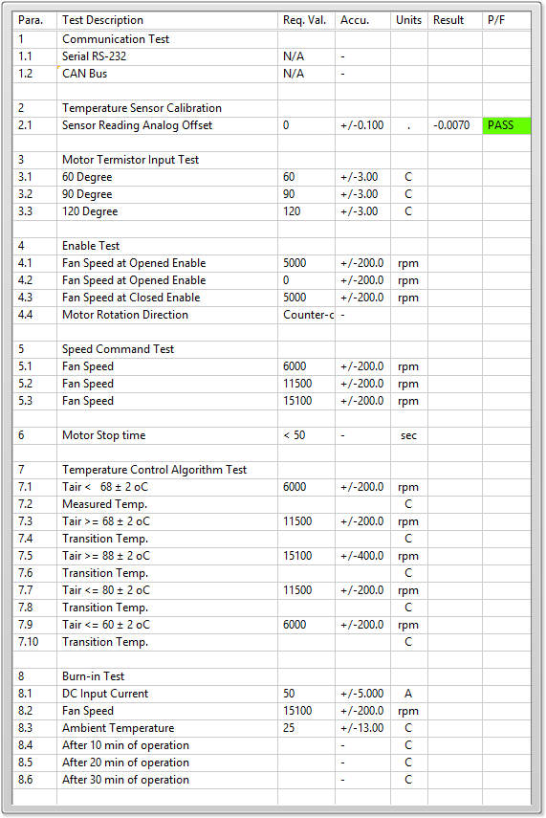

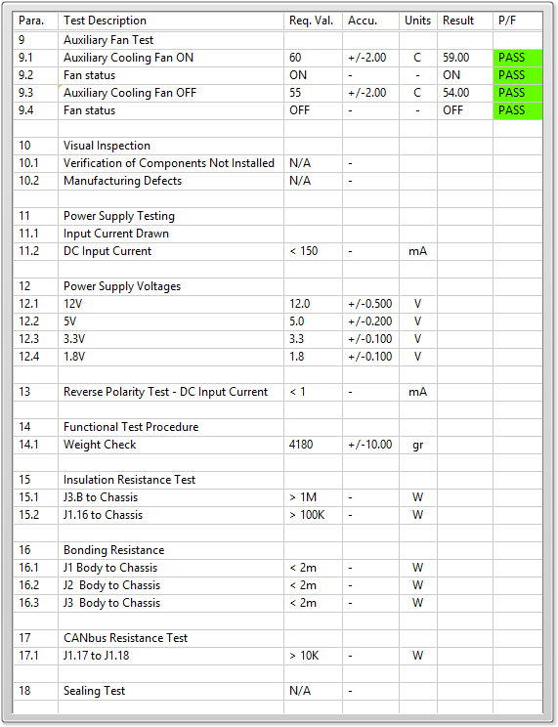

General result:

Test-Operator:____ xs_________ Q.A.:__________________________